# Version management of PowerBI content

* Author: Hamza Tariq

The instructions you provided seem to be a step-by-step guide for integrating Power BI with Git for version control. However, some additional information and clarification are needed to ensure a smooth integration process. Here's a more detailed explanation of the steps:

### 1. Enable Power BI Project (pbib) Save Option:

- Open Power BI Desktop.

- Go to "File" -> "Options and settings" -> "Options."

- In the Options dialog, go to "Preview Features."

- Check the box for "Power BI Project (pbib) save option."

- Click "OK" to save your changes.

### 2. Restart Power BI:

- Close and reopen Power BI Desktop to ensure the preview feature is active.

### 3. Save as a Power BI Project File (.pbib):

- Open the Power BI file you want to integrate with Git.

- Go to "File" -> "Save As."

- Select "Power BI Project files (.pbib)" as the save type.

- Choose a location and save your file as a .pbib project.

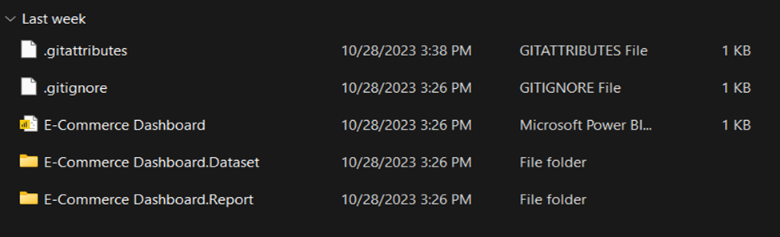

### 4. Integrate the Power BI Project with Git:

- Install Git Desktop application (or any other Git client like Git for Windows).

- Sign in or sign up for a Git service like GitHub or GitLab.

### 5. Add Existing Repository:

- Open the Git Desktop application.

- Click on "File" -> "Add Existing Repository."

- Browse to the location of your Power BI project file.

### 6. Initialize a Git Repository:

- If Git Desktop doesn't recognize the directory as a Git repository, it will prompt you with a message: "The directory does not appear to be a Git repository. Would you like to create a repository here instead?"

- Click on "Create a repository."

- Provide a name for your Git repository and click "Create."

### 7. Publish the Repository:

- In Git Desktop, click on "Publish repository."

- It will publish your repository to a remote Git server like GitHub.

### 8. View the Repository on GitHub:

- After publishing, you can click on "View on GitHub" to open the repository in your web browser.

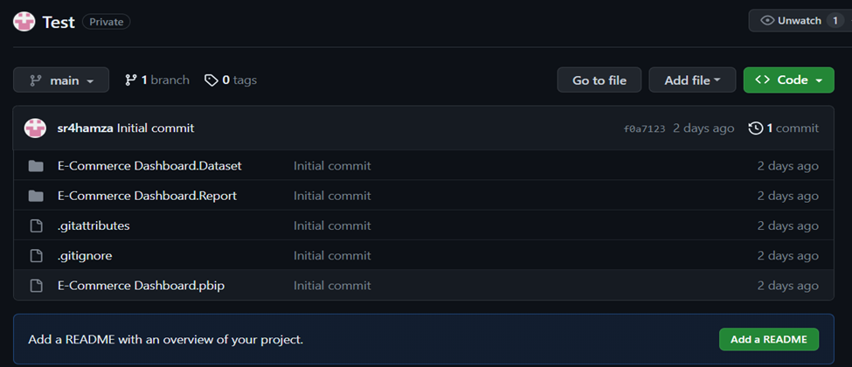

### 9. Congratulations! Integration with Git is Complete.

### 10. Version Management with Git:

- After completing the integration, you can use Git for version control.

- Any changes you make to your Power BI project will be detected by Git Desktop.

### 11. Commit Changes:

- Git Desktop will show you the changes in the .bim file.

- Review the changes, add a summary and description of the changes, and click "Commit."

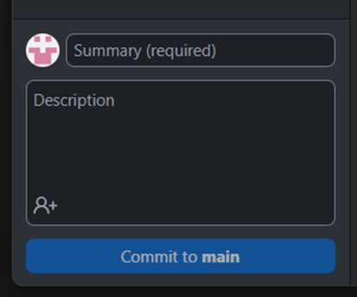

### 12. Push Changes to the Remote Repository:

- After committing, click "Push Origin" to upload your changes to the remote repository (e.g., GitHub).

- Your changes will be reflected in the Git repository, and version control is established.

### <Diffing/merging conflict resolution to be added>

By following these steps, you will have successfully integrated Power BI with Git for version control and can manage your Power BI project collaboratively and track changes over time.

Reference Video Link:<https://www.youtube.com/watch?v=PDI3k4G4Dpk&t=665s>